** BHARATHIDASAN ENGINEERING COLLEGE**

**NATTRAMPALLI 635852**

**FOOD TRACKING SYSTEM USING BLOCKCHAIN TECHNOLOGY.**

***Submitted By:***

**SWETHA S**

**BHUVANESHWARI T**

**VARALAKSHMI S**

**JAISREE V**

**FOOD TRACKING SYSTEM USING BLOCK CHAIN TECHNOLOGY**

1. **INTRODUCTION**

1.1 Project Overview

1.2 Purpose

2**. LITERATURE SURVEYEY**

2.1 Existing problem

2.2 References

2.3 Problem Statement Definition

3. **IDEATION & PROPOSED SOLUTION**

3.1 Empathy Map Canvas

3.2 Ideation & Brainstorming

4. **REQUIREMENT ANALYSIS**

4.1 Functional requirement

4.2 Non-Functional requirements

5**. PROJECT DESIGN**

5.1 Data Flow Diagrams & User Stories

5.2 Solution Architecture

6. **PROJECT PLANNING & SCHEDULING**

6.1 Technical Architecture

7. **SOURCE CODE**

8**. RESULTS**

8.1 Output Screenshots

10. **ADVANTAGES & DISADVANTAGES**

11**. CONCLUSION**

12. **FUTURE SCOPE**

**INTRODUCTION:**

A food shortage, which has increased with the climate crisis, will be one of the biggest problems of the world, together with water scarcity, in the future and will damage the sustainability of the food supply system**.** A With the effect of the COVID-19 pandemic, food resources are decreasing, and food prices are rising all over the world. The decrease in food sources increases the importance of food tracking even more. The exorbitant price increases after the COVID-19 pandemic are the most concrete indicators of this. Blockchain-based food tracking systems will be of critical importance because they will prevent exorbitant price increases with their contribution to food tracking processes, such as reliability and transparency.

In this study, the establishment of a blockchain-based food tracking system in Turkey, its operation, and its results will be discussed. It was concluded that 97.54% of the participants using the established system found the application useful and wanted such an application to become widespread. In addition, comparing the performance data of the established blockchain-based system with other blockchain infrastructures, a value of 0.038 s for latency is 435 times better than Ethereum, one of the most popular blockchain infrastructures. A transmission per second value of 285, reception per second value of 335, and CPU load rate value of 19.22 are obtained with the proposed system.

**PROJECT OVERVIEW:**

great importance that food be safe in order to lead a healthy life. Access to and the consumption of safe food is a right that every person should have. Food safety covers the whole process from the production The awareness of protecting human health, which has increased on a global scale in recent years, has also shown itself in the food industry, and it has gained stage of the food until it reaches the consumer. More than 60% or about 1 billion tons of food is wasted within the supply chain while harvesting, processing, shipping, and storing. For instance, nearly 492 million tons of perishable food were wasted in the year 2011 because of the ineffective and poor management of the food tracking systems.

According to the FAO (UN Food and Agriculture Organization), food security is defined as the ability of every person to have access to sufficient, safe, and nutritious food at all times to lead an active and healthy life. Food safety is possible by taking every step of the food under control in the whole process, starting from the raw material until it reaches our table. Especially with the spread of digitalization, it is expected that the number and success of food tracking systems will increase. The benefits of digitalization will be most clearly and largely achieved through the use of emerging technologies.

With the maturation and spread of emerging technologies, it has started to become a part of our daily life, shaping life and paving the way for digitalization. One of the main reasons for digitalization is to reduce or even eliminate the need for manpower. Undoubtedly, one of the prominent technologies at this point is blockchain technology, which is the infrastructure of cryptocurrencies such as Bitcoin, and many application areas have begun to emerge with the possibility of making transactions without intermediaries. Due to the advantages offered by blockchain technology, it has recently gained the notion of being the technological basis on which many applications are developed. It can be used in many different areas, such as smart city applications, IoT, health, energy management, and land registration systems. Blockchain-based security approaches in remote patient monitoring using IoT devices are seen in the literature. In addition, blockchain-based cryptographic technologies could be used for deployment in the IoT. Moreover, especially in recent times, we see that blockchain technology is used even in social media and content management, which is the abandonment of daily life. It is even seen that a naive blockchain- and watermarking-based social media framework is proposed to control fake news propagation. As can be seen from all these examples, it is seen that blockchain technology can be applied in many different areas and the results obtained to make a significant contribution.

**PURPOSE:**

To define blockchain technology, it is a technology that eliminates the need for a central trust or authority, allowing trust to be distributed to the participants in the system. This technology can be defined as a decentralized database, and it is a chain of blocks, each of which contains numerical information. These blocks store a set of information or data in general terms. These sets of information hold more transactional information than storing data such as videos or images. After being filled with transactional data, the blocks are chained to the previous filled block. It also contains information such as the time the block was created (timestamp), the hash code of the block, the hash code of the previous block, the index information, and the nonce value. In the blockchain network, there are copies of the database at all parties of the distributed system

Keeping each of these copies in a distributed manner causes the data to be taken from a single center and moved to live in a multi-environment, making it difficult for potential attackers to be successful. When transactional information arrives on the network, this information is transmitted to nodes in the network. All nodes in the network record this transactional information in their block. It should be noted here that a copy of the blockchain is kept on all the nodes. Once the blocks are filled with enough transaction information (or even just one transaction information), this block needs to be added to the blockchain. When the advantages offered by the blockchain technology and the beneficial results obtained in the application examples are evaluated, it is seen that it can be used in many different areas, determined by the needs. One of these areas is food tracking, which will be one of the most important problems of today and possibly the future. This emerging technology has the potential to take food tracking systems to a new dimension.

A food shortage, which has increased with the climate crisis, will be one of the biggest problems of the world, together with water scarcity, in the future and will damage the sustainability of the food supply system. With the effect of the COVID-19 pandemic, food resources are decreasing, and food prices are rising all over the world. The decrease in food sources increases the importance of food tracking even more. The exorbitant price increases after the COVID-19 pandemic are the most concrete indicators of this. Blockchain-based food tracking systems will be of critical importance because they will prevent exorbitant price increases with their contribution to food tracking processes, such as reliability and transparency. In this study, the establishment of a blockchain-based food tracking system in Turkey, its performance comparison, the operation of the system, and the results will be discussed.

**LITERATURE SURVEY:**

One of the foremost blockchain-based food tracking systems is the “Food Trust” system developed by IBM. Announced for the first time in 2017, Food Trust has provided traceability in the food supply chain to 80 different brands so far by using blockchain technology. With this traceability, the supply process from producers to consumers can be followed in detail. IBM’s open-source technology based on Hyperledger Fabric allows companies to set their own rules on the system. It is argued that the traceability offered by the Food Trust not only helps food safety but also helps producers with food freshness, sustainability, and waste. Announcing that more than 5 million food products already on the shelves are included in the system, IBM seems confident that this platform will grow strongly. Among the companies using this application are giants such as Dile, Kroger, McCormick and Company, Nestle, Tyson Foods, and Unilever.

Walmart has used blockchain to record where every piece of meat it buys from China comes from, where it is processed, where it is stored, and all transactions related to its sale, along with its historical course. All detailed information about the farm where the meat comes from, the factory where it is processed, the batch number of the product, the storage temperature of the product, and transportation can be tracked on the blockchain. In addition to the benefits of processing speed, information sharing, and transparency, the main purpose is summarized as increasing food safety.

Provenance has conducted a blockchain-based pilot project in Indonesia to transparently track the movement of products from sea to table in the fishing industry. The seafood trade consists of a very large fishing network, and it is a very difficult sector to control quality. There is no reliable audit in the sector. This project aims to help stop illegal, excessive, harmful to the sea and the environment, and non-sanitary fishing violations in the tuna fish industry. Thus, consumers will be able to view the source of the food they supply transparently, and a legal basis will be established to combat illegal fishing. With the use of this example, the aim is that the use of blockchain technology will facilitate transparency, tracking, and auditing, thus ensuring the safety of food products, preventing illegal and excessive fishing, and preventing damage to the environment.

Kim proposes a blockchain-based traceability system with different ontologies, where each one could accomplish and be part of certain transactions. He offers the use of smart contracts. Ethereum, with the Solidity programming language, was used in his study. Feng Tian et al. propose a blockchain solution for agriculture traceability to ensure that the HACCP principles and requirements are addressed during the production, transportation, and preservation of a product.

Moreover, Daniel Tse et al. focus on the increasingly serious problem of food safety in China and propose a blockchain solution for the agriculture supply chain, based on the information and transaction security between all the involved parties. In this work, a PEST (political, economic, social, and technological) environment analysis took place to define the challenges and the opportunities of the DLT (Distributed Ledger Technologies) solution.

In addition, Francesco Marinello et al. offer a blockchain-based solution focusing on the animal products supply chain in Italy. Kumar et al. propose a rice supply chain system that uses blockchain technology to assure the safety of rice during its flow through the supply chain.

Maria Elena Latino et al. propose another interesting idea regarding the agriculture supply chain and the use of Industry 4.0 principles. They refer to the idea of food democracy, according to which consumers are considered citizens and the food is not a good but a civil right. The authors advertise the idea of voluntary traceability and combine it with Industry 4.0 technologies. The significance of voluntary traceability is highlighted, focusing on the volume and the quality of the data collected for each product, as well as the need for a big data platform to handle them.

Islam and others published work about the visualization of food supply chain management. Their research aims to propose a new visualization approach that allows supply chain operators to collaborate effectively in the design process of FTSs capable of maintaining streamlined information flow, minimizing information loss, and improving supply chain performance.

Bahga et al. proposed work to monitor the food supply chain tracking system on a cloud-based architecture. The proposed system, called CloudTrack, provides the global information of the entire fleet of food supply vehicles and is proposed to be used to track and monitor a large number of vehicles in real time.

Caro et al. propose an integrated solution of a blockchain platform named AgriBlockIoT in the agriculture supply chain. AgriBlockIoT is a fully distributed system that uses blockchain technology in combination with IoT devices to collect and distribute traceability data. The proposed solution was tested with two Ethereum and Hyperledger Sawtooth blockchain platforms.

**IDEATION & PROPOSED SOLUTION:**

The proposes a blockchain-based food tracking system, especially to solve the recent problems related to food tracking in China. Arguing that traditional agricultural supply logistics systems do not fully meet market needs, he proposes a more dynamic RFID-based food supply chain management system. With the proposed system, it is advocated that traceability with reliable information in the entire agri-food supply chain effectively guarantees food safety by collecting, transferring, and sharing the original data of agri-food in production, processing, storage, distribution, and sales connections.

**EMPATHY MAP CANVAS**

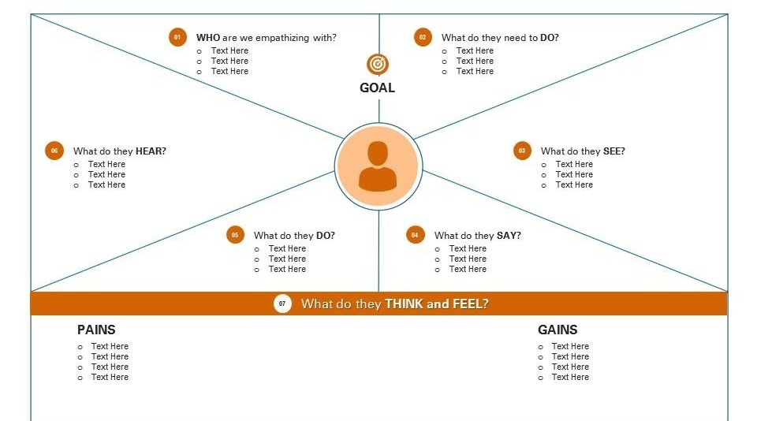

**IDEATION AND BRAINSTORMING:**

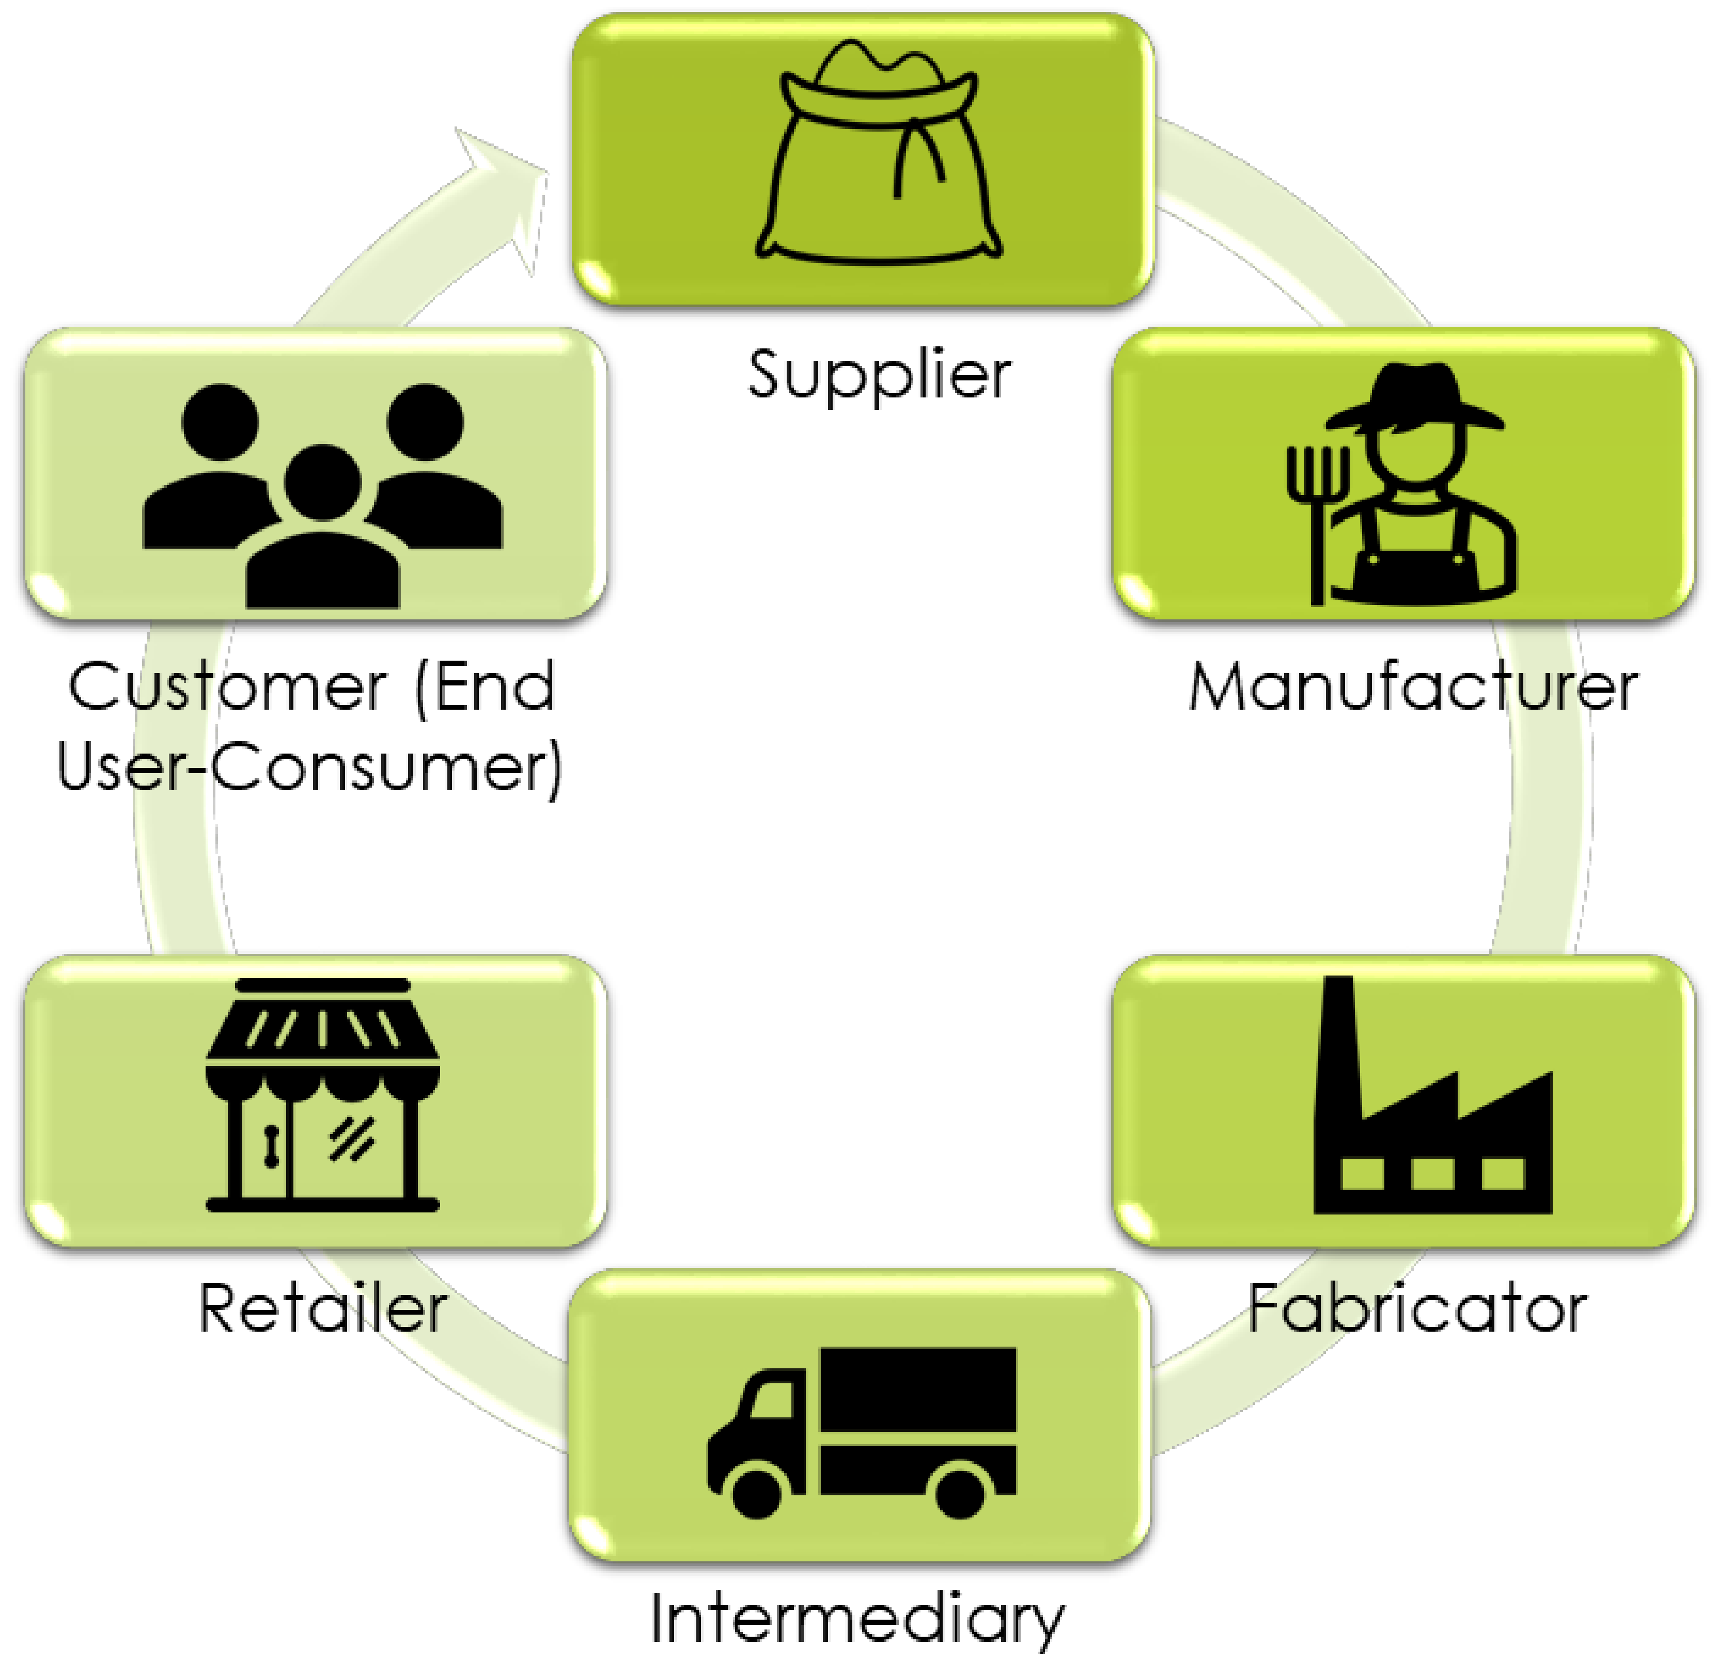

**METHODS FOR FOOD TRACKING SYSTEM:**

**Method:**

With the increasing population, food consumption is also increasing simultaneously. Accordingly, food producers or intermediaries try to reach the highest output level they can produce with their existing capacities to meet this demand and to bring the excess demand to the balance point, but the quality of these products causes various concerns in the consumer. On the other hand, the problems in the economies of the countries after COVID-19 and the decrease in the production of crops cause exorbitant price increases. At this point, the establishment of a blockchain-based food tracking system will be a solution to transparently displaying the process of food products from the soil to the end-user, both easily determining the exorbitant prices and determining the origin of the products correctly. With the system to be established, a tool that can allocate an environment of trust will be obtained. System analysis studies were carried out in line with all these needs. In the current situation, the life cycle of a product from soil to end-users has been examined. For this, various web pages were examined, face-to-face interviews were conducted with sellers and intermediaries, and how this process was carried out was investigated.

When the whole process is examined, seeds and supplement materials are purchased from suppliers, processed by the producer, and turned into products, then wholesaled in factories and delivered to retailers through the distribution chain. Finally, it is offered to the end-user, that is, the consumer.

**Raw material purchase:** Information such as product type, amount of chemical, which is the shopping information between the supplier and the manufacturer, is recorded in the blockchain structure. QR codes can be used to

**Planting the crop:** The producer records the number and type of seeds used during planting in the blockchain structure. With a smart contract to be used here, it can be checked that no more seeds are planted from the seed taken in the previous transaction.

**Cultivation:** With the networked microcontrollers to be used here, information about the growing place of the product, how much water or sun it receives can be added to the blockchain. Again, when there is an anomaly with smart contracts, it can be recorded.

**Harvest:** During the harvest of the planted product, adding the obtained amount to the blockchain with IoT devices can be automated and it can be determined whether the product is organic through the process from seed to harvest.

**Delivery of the product to the fabricator:** Using GPS technology, the delivery process of the product to the fabricator can also be monitored with IoT devices.

**Production:** The amount delivered to the manufacturer can be added to the blockchain. In this way, it is possible to monitor how much loss is incurred in the transfer phase of the goods from the manufacturer to the manufacturer.

**Delivery of the product to the retailer:** Using GPS technology, the delivery process of the product to the retailer can also be monitored with IoT devices. The quantity and freshness of the delivered product can be recorded on the blockchain.

**Consumption:** The consumer can view the entire life cycle of this product, all data collected, with the help of a QR code. They can also observe how the pricing is conducted in all the above transactions.

**PROJECT DESIGN:**

**DATA FLOW DIAGRAM:**

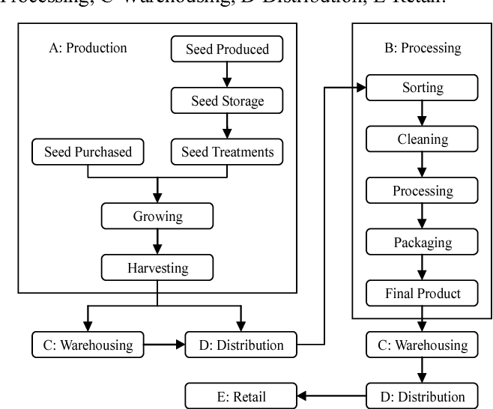

**ARCHITECTURE DIAGRAM:**

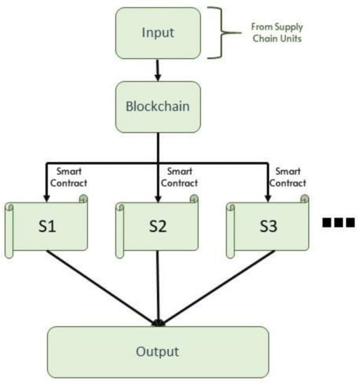

**Proposed layer block chain technology**

The proposed system within the scope of the study, it is recommended to add a blockchain layer in front of the existing source stream layer ([**Figure 5**](https://www.mdpi.com/2079-9292/11/16/2491#fig_body_display_electronics-11-02491-f005)). With the smart contract structure, the aim is to make food tracking more transparent and safe and prevent data destruction.

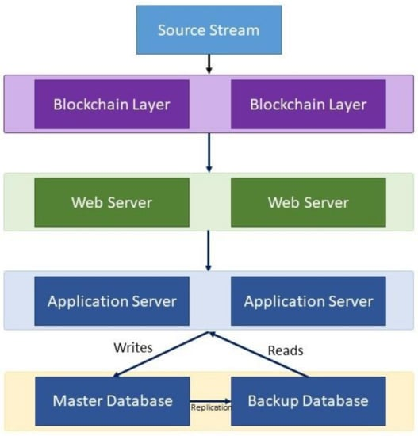

**The proposed blockchain-based food tracking system architecture.**

In the traditional approach, the data obtained from the source are transferred directly to the application layer. At this point, if there is no additional security layer, there may be cyber-attacks in the supply chain. In addition, it is seen that the direct transfer of the obtained data to another source on a single source can only be performed in a closed way. This is an important indication that the principle of transparency does not exist in this structure. With the addition of the blockchain layer, an important line of defense has been established for the security of data. Because advanced cryptography (hash code structure) is used, the probability of successful cyber-attacks on a blockchain-based system is almost impossible. On the other hand, considering that blockchain technology allows the formation of chains by adding blocks end-to-end and the transparent monitoring of this chain, it provides an important advantage for the the ownership of the data does not belong to any party, that is, all participants have a copy of the data in a distributed structure. Thus, a system in which the buyer and seller can transact between themselves without the involvement of any third party will be achieved. In summary, in traditional approaches, while the data from the source is transferred directly to the application server via web services, an additional layer is added to the blockchain layer; security and transparency will be guaranteed. In addition, with this added blockchain layer, the way to manage the entire supply process in a decentralized way will be opened.

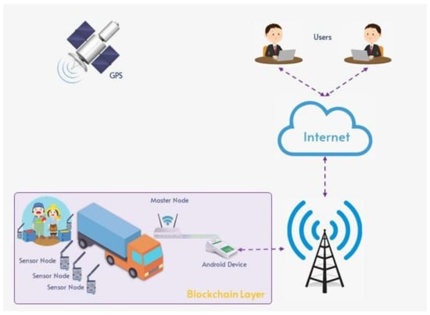

**CODING:**

**FRONTEND PROGRAM:**

**<?xml version="1.0" encoding="UTF-8"?>**

**<projectDescription>**

**<name>FoodTrackingSystem</name>**

**<comment></comment>**

**<projects>**

**</projects>**

**<buildSpec>**

**<buildCommand>**

**<name>org.eclipse.ajdt.core.ajbuilder</name>**

**<arguments>**

**</arguments>**

**</buildCommand>**

**<buildCommand>**

**<name>org.eclipse.wst.common.project.facet.core.builder</name>**

**<arguments>**

**</arguments>**

**</buildCommand>**

**<buildCommand>**

**<name>org.springframework.ide.eclipse.core.springbuilder</name>**

**<arguments>**

**</arguments>**

**</buildCommand>**

**<buildCommand>**

**<name>org.eclipse.wst.jsdt.core.javascriptValidator</name>**

**<arguments>**

**</arguments>**

**</buildCommand>**

**<buildCommand>**

**<name>org.eclipse.wst.validation.validationbuilder</name>**

**<arguments>**

**</arguments>**

**</buildCommand>**

**<buildCommand>**

**<name>org.eclipse.m2e.core.maven2Builder</name>**

**<arguments>**

**</arguments>**

**</buildCommand>**

**</buildSpec>**

**<natures>**

**<nature>org.eclipse.ajdt.ui.ajnature</nature>**

**<nature>org.springframework.ide.eclipse.core.springnature</nature>**

**<nature>org.eclipse.jdt.core.javanature</nature>**

**<nature>org.eclipse.m2e.core.maven2Nature</nature>**

**<nature>org.eclipse.wst.common.project.facet.core.nature</nature>**

**<nature>org.eclipse.wst.common.modulecore.ModuleCoreNature</nature>**

**<nature>org.eclipse.wst.jsdt.core.jsNature</nature>**

**</natures>**

**BACKEND PROGRAM:**

To Creating a complete blockchain-based food tracking system requires a significant amount of code and a deep understanding of blockchain technology. Below is a simplified and high-level example of a smart contract written in Solidity for Ethereum, which can be part of a food tracking system. This contract stores information about food items and their supply chain on the blockchain.

solidity

// SPDX-License-Identifier: MIT

pragma solidity ^0.8.0;

// The FoodTrackingSystem contract

contract FoodTrackingSystem {

struct FoodItem {

uint256 id;

string name;

string origin;

uint256 timestamp;

}

mapping(uint256 => FoodItem) public foodItems;

uint256 public foodItemCount;

event FoodItemAdded(uint256 id, string name, string origin, uint256 timestamp);

// Function to add a new food item to the system

function addFoodItem(string memory _name, string memory _origin) public {

foodItemCount++;

foodItems[foodItemCount] = FoodItem(foodItemCount, _name, _origin, block.timestamp);

emit FoodItemAdded(foodItemCount, _name, _origin, block.timestamp);

}

// Function to get the details of a food item by its ID

function getFoodItem(uint256 id) public view returns (uint256, string memory, string memory, uint256) {

FoodItem memory foodItem = foodItems[id];

return (foodItem.id, foodItem.name, foodItem.origin, foodItem.timestamp);

}

}

This smart contract defines a simple FoodTrackingSystem where users can add food items with a name, origin, and a timestamp. They can also retrieve the details of a specific food item using its ID.

This is just a starting point and there are many features and enhancements that can be added to make the system more robust and secure. Additionally, you will need to develop a user interface and integrate it with the blockchain network using a suitable library like web3.js or ethers.js to interact with the smart contract.

It is highly recommended to consult with experienced blockchain developers or a development agency to ensure the successful implementation of a food tracking system based on blockchain technology.

After the creation of the blockchain network with Hyperledger Fabric, it became clear that there was a need for another tool to transparently display the transactions, channels, and blocks performed on the network. At this point, it was decided to use the “Explorer” tool, which is one of the tools offered by Hyperledger. Explorer can be qualified as a tool that meets all these requirements.

After the infrastructural installations of the network were completed, the stage of making the system operational with the actors determined was carried out.

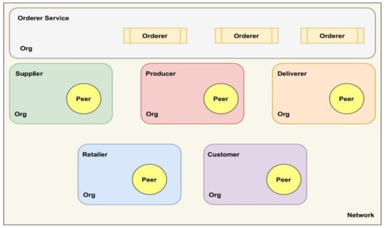

**Parties in the developed network**

The genesis block is the most special block for all systems because it shows that the system is running and is different from other blocks. A file named “configtx.yaml” was created to create the genesis block and define channel permissions. In this created file, the permissions of the organizations, consensus algorithm, channel components, and communication ports were defined. Because this file will be used with multiple commands, a bash script file named “generate-channel-artifacts.sh” was created, which is responsible for the execution of these commands. The genesis block was created with the following code:

* configtxgen -profile AgriOrdererGenesis -outputBlock ./channel-artifacts/genesis.block channelID agriorderergenesis.
* Then, a channel configuration file named “mychannel”, including other organizations, was created and the system was started. The code is given below:
* configtxgen-profile AgriChannel-outputCreateChannelTx./channel-artifacts/channel.tx channelID mychannel.

**OUTPUT & SCREENSHOT:**

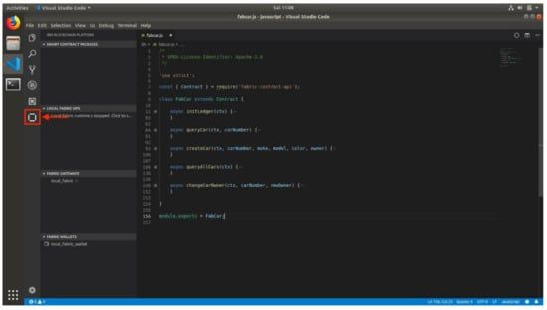

**IBM blockchain platform “VS Code” plugin.**

A smart contract structure that works in line with the system flow determined by using the VS Code interface was obtained. A sample smart contract screenshot over the developed application.

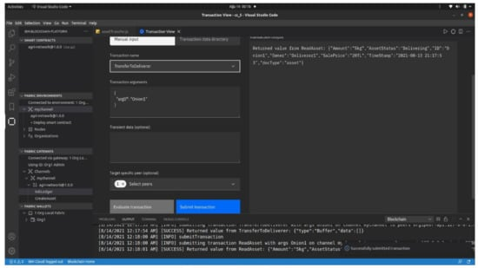

**Food tracking system smart contract screen.**

**Results**

Before using the blockchain-based food tracking system, the performance data of the system were obtained. In this way, it will be necessary to prevent problems such as scalability and to stop the work if it is foreseen that the blockchain-based system to be used will not reach the desired performance values. The performance values of Ethereum and Hyperledger Sawtooth are used to benchmark the values obtained from the proposed system. A simulation environment has been set up to collect and compare these data using Matlab. The latency (s), Net Tx (bytes), Net Rx (bytes), and CPU load (%) values are the variables that keep the data obtained in this simulation environment. With the data obtained in this simulation environment, the aim is to reveal the difference with other platforms clearly and concretely.

The latency (s) value in the proposed system was obtained as 0.038. The transmission per second value is 285, the reception per second value is 335, and the CPU load rate value is 19.22. Especially when we evaluate the latency times, the obtained value is at a very good level compared to Ethereum. When it is compared with Hyperledger Sawtooth, it is seen that there is a little more delay. The main reason for this is that the system architecture is more complicated, and the data size obtained is high. This is also evident from the fact that the transmission per second and reception per second values are much higher than Hyperledger Sawtooth. It has been observed that a rate of 19.22 was achieved in the CPU usage rate. As a result, it is seen that the performance data obtained have a serious advantage over Ethereum, especially in terms of latency, and it has started to converge in other values. Considering that the real-time operation of the installed system is extremely important, the choice of Hyperledger Fabric has once again emerged as the right decision.

After demonstrating that the performance data of the installed blockchain-based food tracking system are satisfactory and provide serious advantages, it is necessary to work on putting the system into use. The next step after the installation of the system is to put it into use, first in the pilot region and then across the country. Currently, a study on UDTS (Product Verification and Tracking System) has been carried out in Turkey and it was put into use at the end of 2018 by the Republic of Turkey Ministry of Agriculture and Forestry. Although blockchain technology is not used in this project, within the scope of this study, the aim is to follow the food of the following products through a system, under government control:

* Supplements;
* Honey;
* Energy drinks;
* Black tea;
* Vegetable oils;
* Baby foods.

Although such a useful application was developed, it was not widely used. The main reasons for this can be listed as the lack of transparency, the need for continuous central control, and the inability to provide the right access to the end-user. Because the application we have developed is blockchain-based, we can say that basic restrictions will be eliminated with the provision of transparency and the elimination of the need for a central authority.

Because we did not have the chance to implement our application throughout the country at this stage, we took action to run the application unofficially in a pilot region and decided to implement it in a market. Therefore, we agreed to pilot the application we developed with a branch of big market chains that are open to technological innovations and have a large customer circulation in Ankara, the capital city of Turkey. With the study to be carried out in the pilot region, the aim is to evaluate the feedback that the system will receive from the users. In case the feedback is positive, the aim is to provide a basis for use throughout the country and to obtain a solid evidence base so that the performance values can be obtained from real usage data.

With the announcements in the grocery section where tomato and potato vegetables are located, we made the participants be included in the system by reading the QR code to the volunteers. Surely, we both obtained the food tracking adventures of tomatoes and potatoes on sale from the UTDS system and contacted the producers at the missing points. As a result of the studies that we carried out for 3 months (October–December 2021), we asked short survey questions of two questions each to the participants.

During this period, a total of 7828 users viewed the application. While 5560 users logged into the application and had a user experience, 2268 users did not prefer to use the application despite seeing it and continued their shop. We see that the number of users who use the application after seeing it is 72.03%. Although we hoped to encounter a higher rate in this period of accelerating digitalization, the reason for this number to remain low may be due to the elderly and people who do not have or do not prefer to use smartphones. In addition, participants who are in a hurry can also be considered as one of the reasons for this rate. When we evaluate all these, we can say that the rate of 72.03% is not very low and that people are open to innovation.

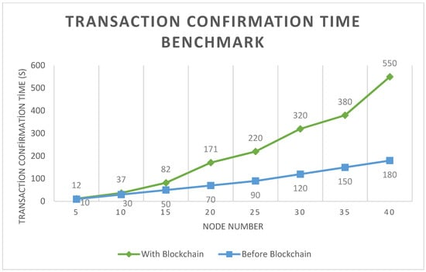

**Benchmark of transaction confirmation time (with and without blockchain layer).**

**ADVANTAGES OF FOOD TRACKING SYSTEM:**

**Food Traceability:**

It is easier to track the journey of the food items from farm to fork. It can help to reduce the risk food fraud and improve food safety. Each participant in the food supply chain records information about their products on a blockchain ledger.

**Transparency:**

By providing a shared record of all transactions, blockchain can increase transparency in the food supply chain. This can help to built trust between different parties, such as farmers, processors, retailers and consumers. This can help identify and address issues related to food safety, quality and sustainability.

**Efficiency:**

It also reduces the time and cost associated with manual record- keeping and data sharing. It eliminates the need for intermediaries, such as brokers and distributors, in the food supply chain. It can be executed faster, more secure, reliability and reduce the risk of errors and fraud.

**Smart Contracts:**

It can enable the use of smart contracts, which are self- executing contracts with the terms of the agreement between buyer and seller being directly written into values of code. It can be record and monitor data on food quality and safety, including information on the source of the food.

**Improved Inventory Management:**

It can help to optimize inventory management by providing real – time tracking of food products throughout the supply chain. This allows stakeholders to more accurately predict demand and reduce waste. This helps prevent stockouts by ensuring the timely delivery of food products.

**Better Compliance with Regulations:**

It is possible by providing an immutable record of all transactions in the food supply chain. This helps stakeholders to quickly and easily demonstrate compliance and avoid potential penalties. This helps to prevent fraud, reduce errors and ensure compliance with regulations.

**CONCLUSION:**

It has the potential to revolutionize the food tracking system by enhancing transparency, traceability, food safety, and supply chain management. The consumers can access detailed information about the food they consume such as it origin, ingredients, and production processes, fostering trust and confidence in the food industry.

The automation and streamlining of supply chain processes using block chain can optimize efficiency, reducing paperwork and manual errors, while potentially leading to cost savings for businesses.

Overall, the implementation of blockchain technology in food tracking systems has the potential to revolutionize the industry, improving safety standards, consumer trust, and supply chain management.

**FUTURE SCOPE:**

The future scope of food tracking system in blockchain technology is promising, with several potential advancements and applications.

Integrating the technology with the Internet of Things (IoT) can enable real – time data collection from sensors and devices embedded in the food supply chain.

This can be expansive, and the use of smart contracts, certification and auditing processes, supply chain optimization, consumer engagement, provenance certification, and data analytics all hold significant potential for advancing food safety, transparency, and sustainability.

This innovations and the improvements in the food tracking systems of the future to continuously evolves the advancing food safety techniques of the future.